Figure 2:

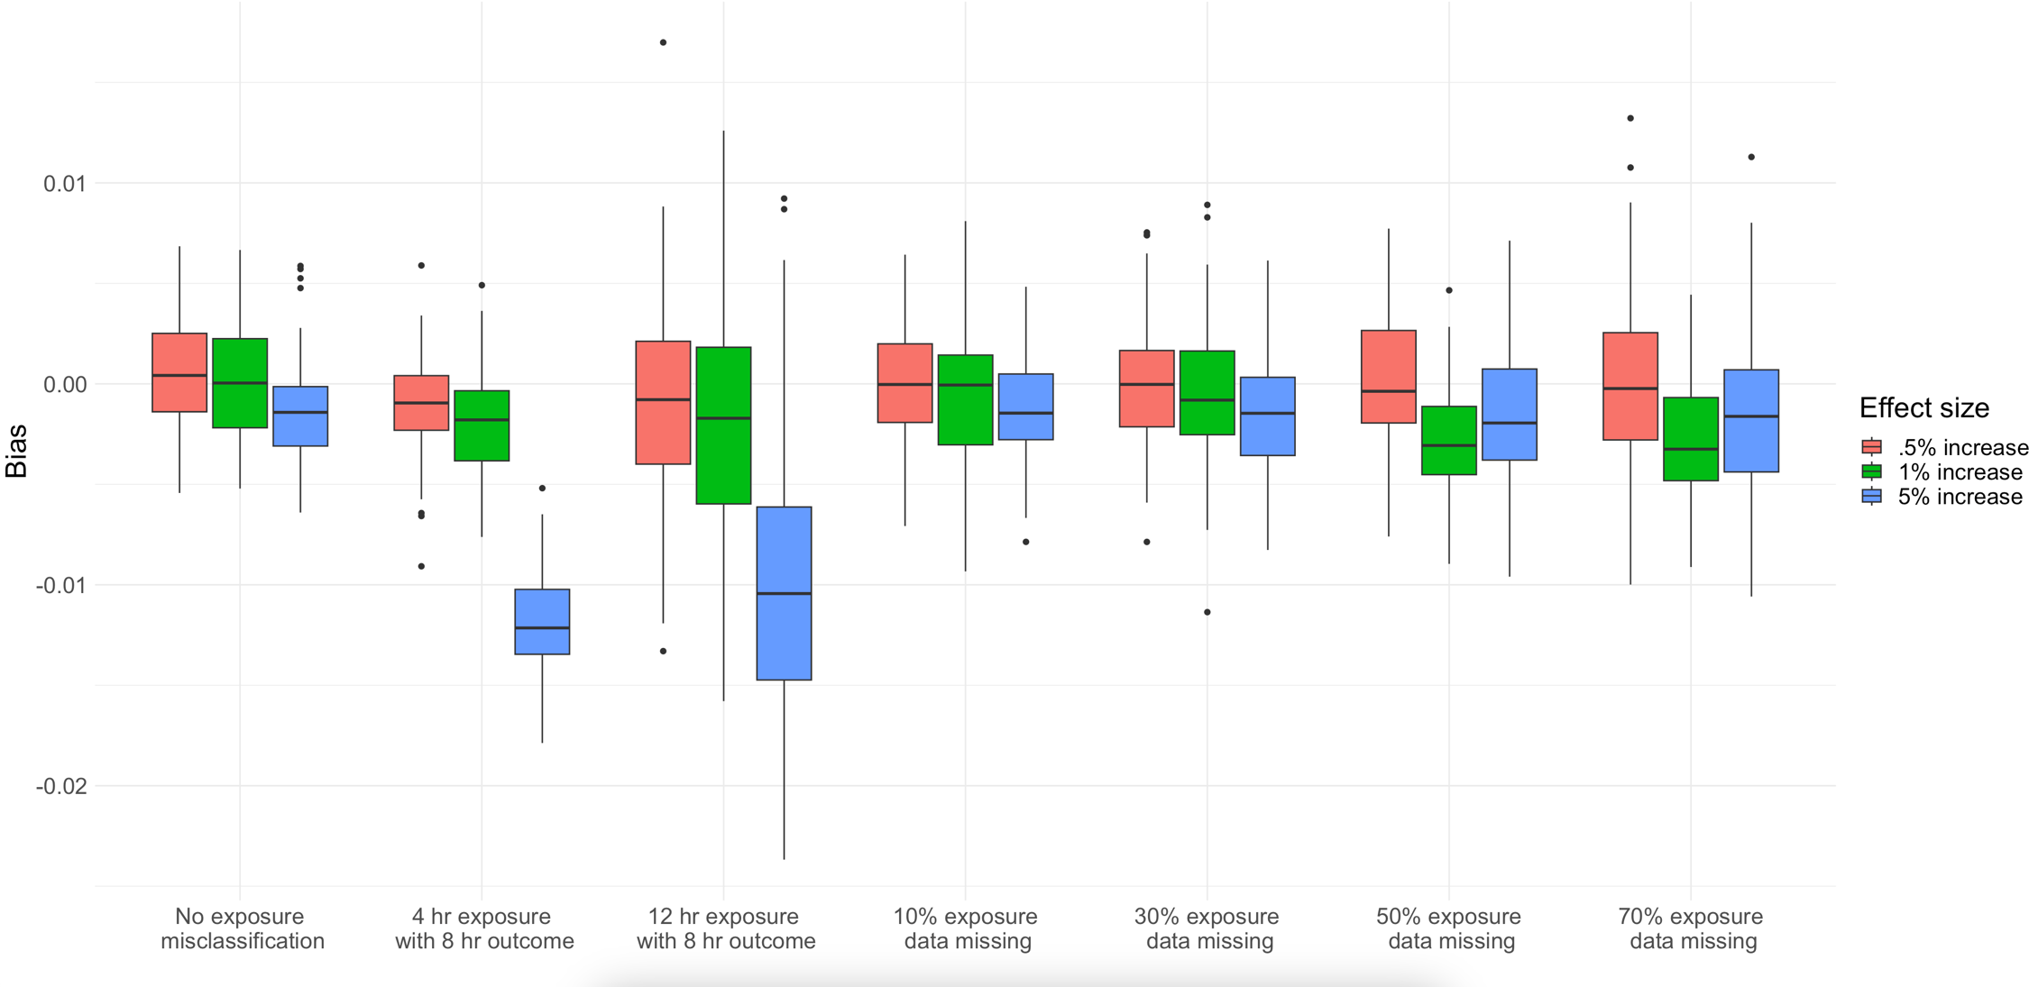

Notes on this figure (I’ll write a real description later). These boxplots are of bias: (*𝑙𝑛*(*𝛽*ˆ)−*𝑙𝑛*(*𝛽*)). Each dot in each boxplot is the bias of one effect estimate from a logistic regression relating daily binary county-level power outage exposure to daily county-level hospitalization rates, using one year of simulated power outage and hospitalization data. Each simulation was run 100 times, so each boxplot contains 100 observations. Each group of three boxplots is from the same simulation representing an exposure misclassification scenario, either modelling a scenario where there was missing power outage data, or a scenario where the clinically relevant length of power outage was misidentified. We repeated each simulation three times, varying the effect estimates. That’s the color of the boxplots.

Figure 1:

